Hackathon Project Phases Template for the HealthAI project.

Hackathon Project Phases Template

Project Title:

HealthAI – Intelligent Healthcare AssistantTeam Name

Team Members:
- Saikarthik Ambati
- ChandanaPriya Dontu

Phase-1: Brainstorming & Ideation

Objective:

Develop an AI-powered intelligent healthcare support system using IBM Granite LLM to optimize clinical decision-making, personalize treatment plans, and provide patients with 24/7 access to medical advice.

Key Points:
- Problem Statement:
  - Many patients struggle to access timely medical advice, especially in rural or underserved areas.
  - Healthcare providers face administrative burdens that reduce time available for patient care.
  - Misdiagnoses and delayed treatments lead to poor health outcomes.
  - Healthcare disparities exist due to geographical and socio-economic difference.
- Proposed Solution:
  - An AI-powered healthcare assistant using IBM Granite LLM for intelligent diagnostics and personalized treatment recommendations.
  - 24/7 conversational AI chatbot for real-time patient engagement and medical guidance.
  - Automated workflow management for appointment scheduling and medical record processing.
  - Integration with existing healthcare infrastructure and EHR systems.
- Target Users:

○ Healthcare providers looking to optimize clinical decision-making.
○ Hospital administrators aiming to improve operational efficiency.
○ Patients in rural or underserved areas with limited healthcare acces.

Expected Outcome:
○ A functional AI-powered healthcare assistant that provides accurate medical insights, personalized treatment plans, and seamless patient engagement.

Phase-2: Requirement Analysis

Objective:

Define the technical and functional requirements for the HealthAI system.

Key Points:
- Technical Requirements:

○ Programming Language: Python.
  - AI Model: IBM Granite LLM .
  - Frameworks: LangChain, Hugging Face, TensorFlow.
  - Data Processing: Pandas, NumPy.
  - Frontend: Streamlit.
  - Backend: FastAPI, Flask.
  - Data Integration: Medical APIs, Clinical datasets.
- Functional Requirements:
  - AI-powered diagnostic assistance with pattern recognition
  - Personalized treatment plan generation based on patient history.
  - Real-time conversational AI for patient inquiries.
  - Automated workflow management for administrative tasks .
  - Integration capabilities with EHR and hospital systems.
  - Patient portal and doctor dashboard interfaces.
- Constraints & Challenges:
  - Ensuring HIPAA compliance and patient data privacy.
  - Managing AI model accuracy for medical recommendations.
  - Integrating with diverse hospital management systems.
  - Handling API rate limits and optimizing API calls.
  - Handling real-time processing demands

Phase-3: Project Design

Objective:
Develop the architecture and user flow of the HealthAI applicatin.
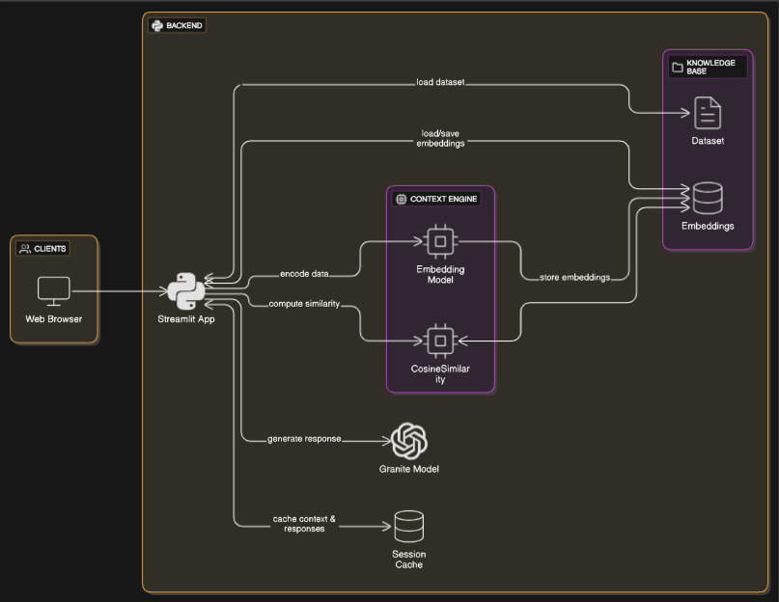

Key Points:
- System Architecture:
  - Patient/Doctor enters medical query via UI.
  - Query processed through IBM Granite LLM with medical context.
  - AI model analyzes patient data and medical patterns.
  - System generates diagnostic insights and treatment recommendations.
  - Results displayed through intuitive dashboards and interfaces.
- User Flow:
  - Step 1: User inputs symptoms, medical history, or diagnostic query.
  - Step 2: Backend processes query using IBM Granite LLM and medical datasets.
  - Step 3: AI analyzes patterns and generates personalized recommendations.
  - Step 4: Results displayed with diagnostic insights and treatment options.
- UI/UX Considerations:
  - Clean, medical-grade interface for professional healthcare environments.
  - Separate portals for patients and healthcare providers.
  - Mobile-responsive design for accessibility.
  - Secure authentication and data privacy controls.

Phase-4: Project Planning (Agile Methodologies)

Objective:

Break down development tasks for efficient completion.

Sprint | Task | Priority | Duration | Deadline | Assigned To | Dependencies | Expected Outcome
Sprint 1 | Environment Setup & API Integration | 🔴 High | 6 hours (Day 1) | End of Day 1 | Saikarthik Ambati | IBM API Key, Python setup | LangChain AI model connection established
Sprint 1 | Medical Dataset Integration | 🟡 Medium | 4 hours (Day 1) | End of Day 1 | Chandana Priya Dontu | Clinical datasets | API access Data pipeline working
Sprint 2 | AI Diagnostic Logic Development | 🔴 High | 5 hours (Day 2) | Mid-Day 2 | Saikarthik Ambati | Model integration | datasets ready Core AI functionality
Sprint 2 | Frontend UI Development | 🔴 Medium | 3 hours (Day 2) | Mid-Day 2 | Chandana Priya Dontu | API logs, UI inputs | AI response format Patient and doctor interfaces
Sprint 3 | Testing & Healthcare Compliance | 🟡 Medium | 1.5 hours (Day 2) | Mid-Day 2 | Both team Members | Working prototype | HIPAA-compliant system
Sprint 3 | Final Presentation & Deployment | 🟢 Low | 1 hour (Day 2) | End of Day 2 | Entire Team | Working prototype | Complete system Demo-ready healthcare assistant  Sprint Planning with Priorities

Sprint Planning with Priorities

Sprint 1 – Setup & Integration (Day 1)
(🔴 High Priority) Set up development environment with IBM Granite LLM
(🔴 High Priority) Integrate medical datasets and Healthcare APIs
(🟡 Medium Priority) Build basic authentication and security framework.

Sprint 2 –Core AI Features & Interface (Day 2)

(🔴 High Priority) Test AI accuracy and healthcare compliance.

(🟡 Medium Priority) Optimize performance and user experience.

(🟢 Low Priority) Prepare final demonstration and deployment

Sprint 3 – Testing, Compliance & Deployment (Day 2)
(🟡 Medium Priority) Test API responses, refine UI, & fix UI bugs.
(🟢 Low Priority) Final demo preparation & deployment.

Phase-5: Project Development

Objective:

Implement core features of the HealthAI system.

Key Points:
- Technology Stack Used:
  - AI Model: IBM Granite LLM.
  - Frontend: Streamlit .
  - Backend: FastAPI/Flask.
  - Programming Language: Python.
  - Frameworks: LangChain, Hugging Face, TensorFlow.

- Development Process:
  - Implement IBM Granite LLM integration for medical pattern recognition.
  - Develop personalized treatment recommendation algorithms.
  - Create conversational AI interface for patient engagement.
  - Build automated workflow management system ○ Optimize queries for medical accuracy and relevance

Phase-6: Functional & Performance Testing

Objective:

Ensure that the HealthAI system works accurately and safely.
Test Case ID | Category | Test Scenario | Expected Outcome | Status | Tester
TC-001 | Functional Testing | Query "Symptoms: fever, headache, fatigue" | Relevant diagnostic suggestions with treatment options | ✅ Passed | Saikarthik
TC-002 | Functional Testing | Patient history analysis for personalized treatment | Customized treatment plan based on medical history | ✅ Passed | Chandana Priya
TC-003 | Performance Testing | AI response time under 2 seconds for medical queries | System responds quickly with accurate medical insights | ⚠ Needs Optimization | Optimization Both
TC-004 | Security Testing | Patient data encryption and privacy protection | All sensitive data properly encrypted and secured | ✅ Passed | Saikarthik
TC-005 | Compliance Testing | HIPAA compliance validation | System meets healthcare data protection standards | ❌ In Progress | Chandana Priya
TC-006 | Integration Testing | EHR system compatibility | Seamless integration with hospital management systems. | 🚀 Ready for Testing | Both Team Members

Final Submission
- Project Report Based on healthcare AI templates.
- Demo Video (3-5 Minutes) showcasing HealthAI capabilities.
- GitHub/Code Repository Link with complete source code.
- Technical Documentation including API specifications and deployment guide.
- Healthcare Compliance Report detailing privacy and security measures.

